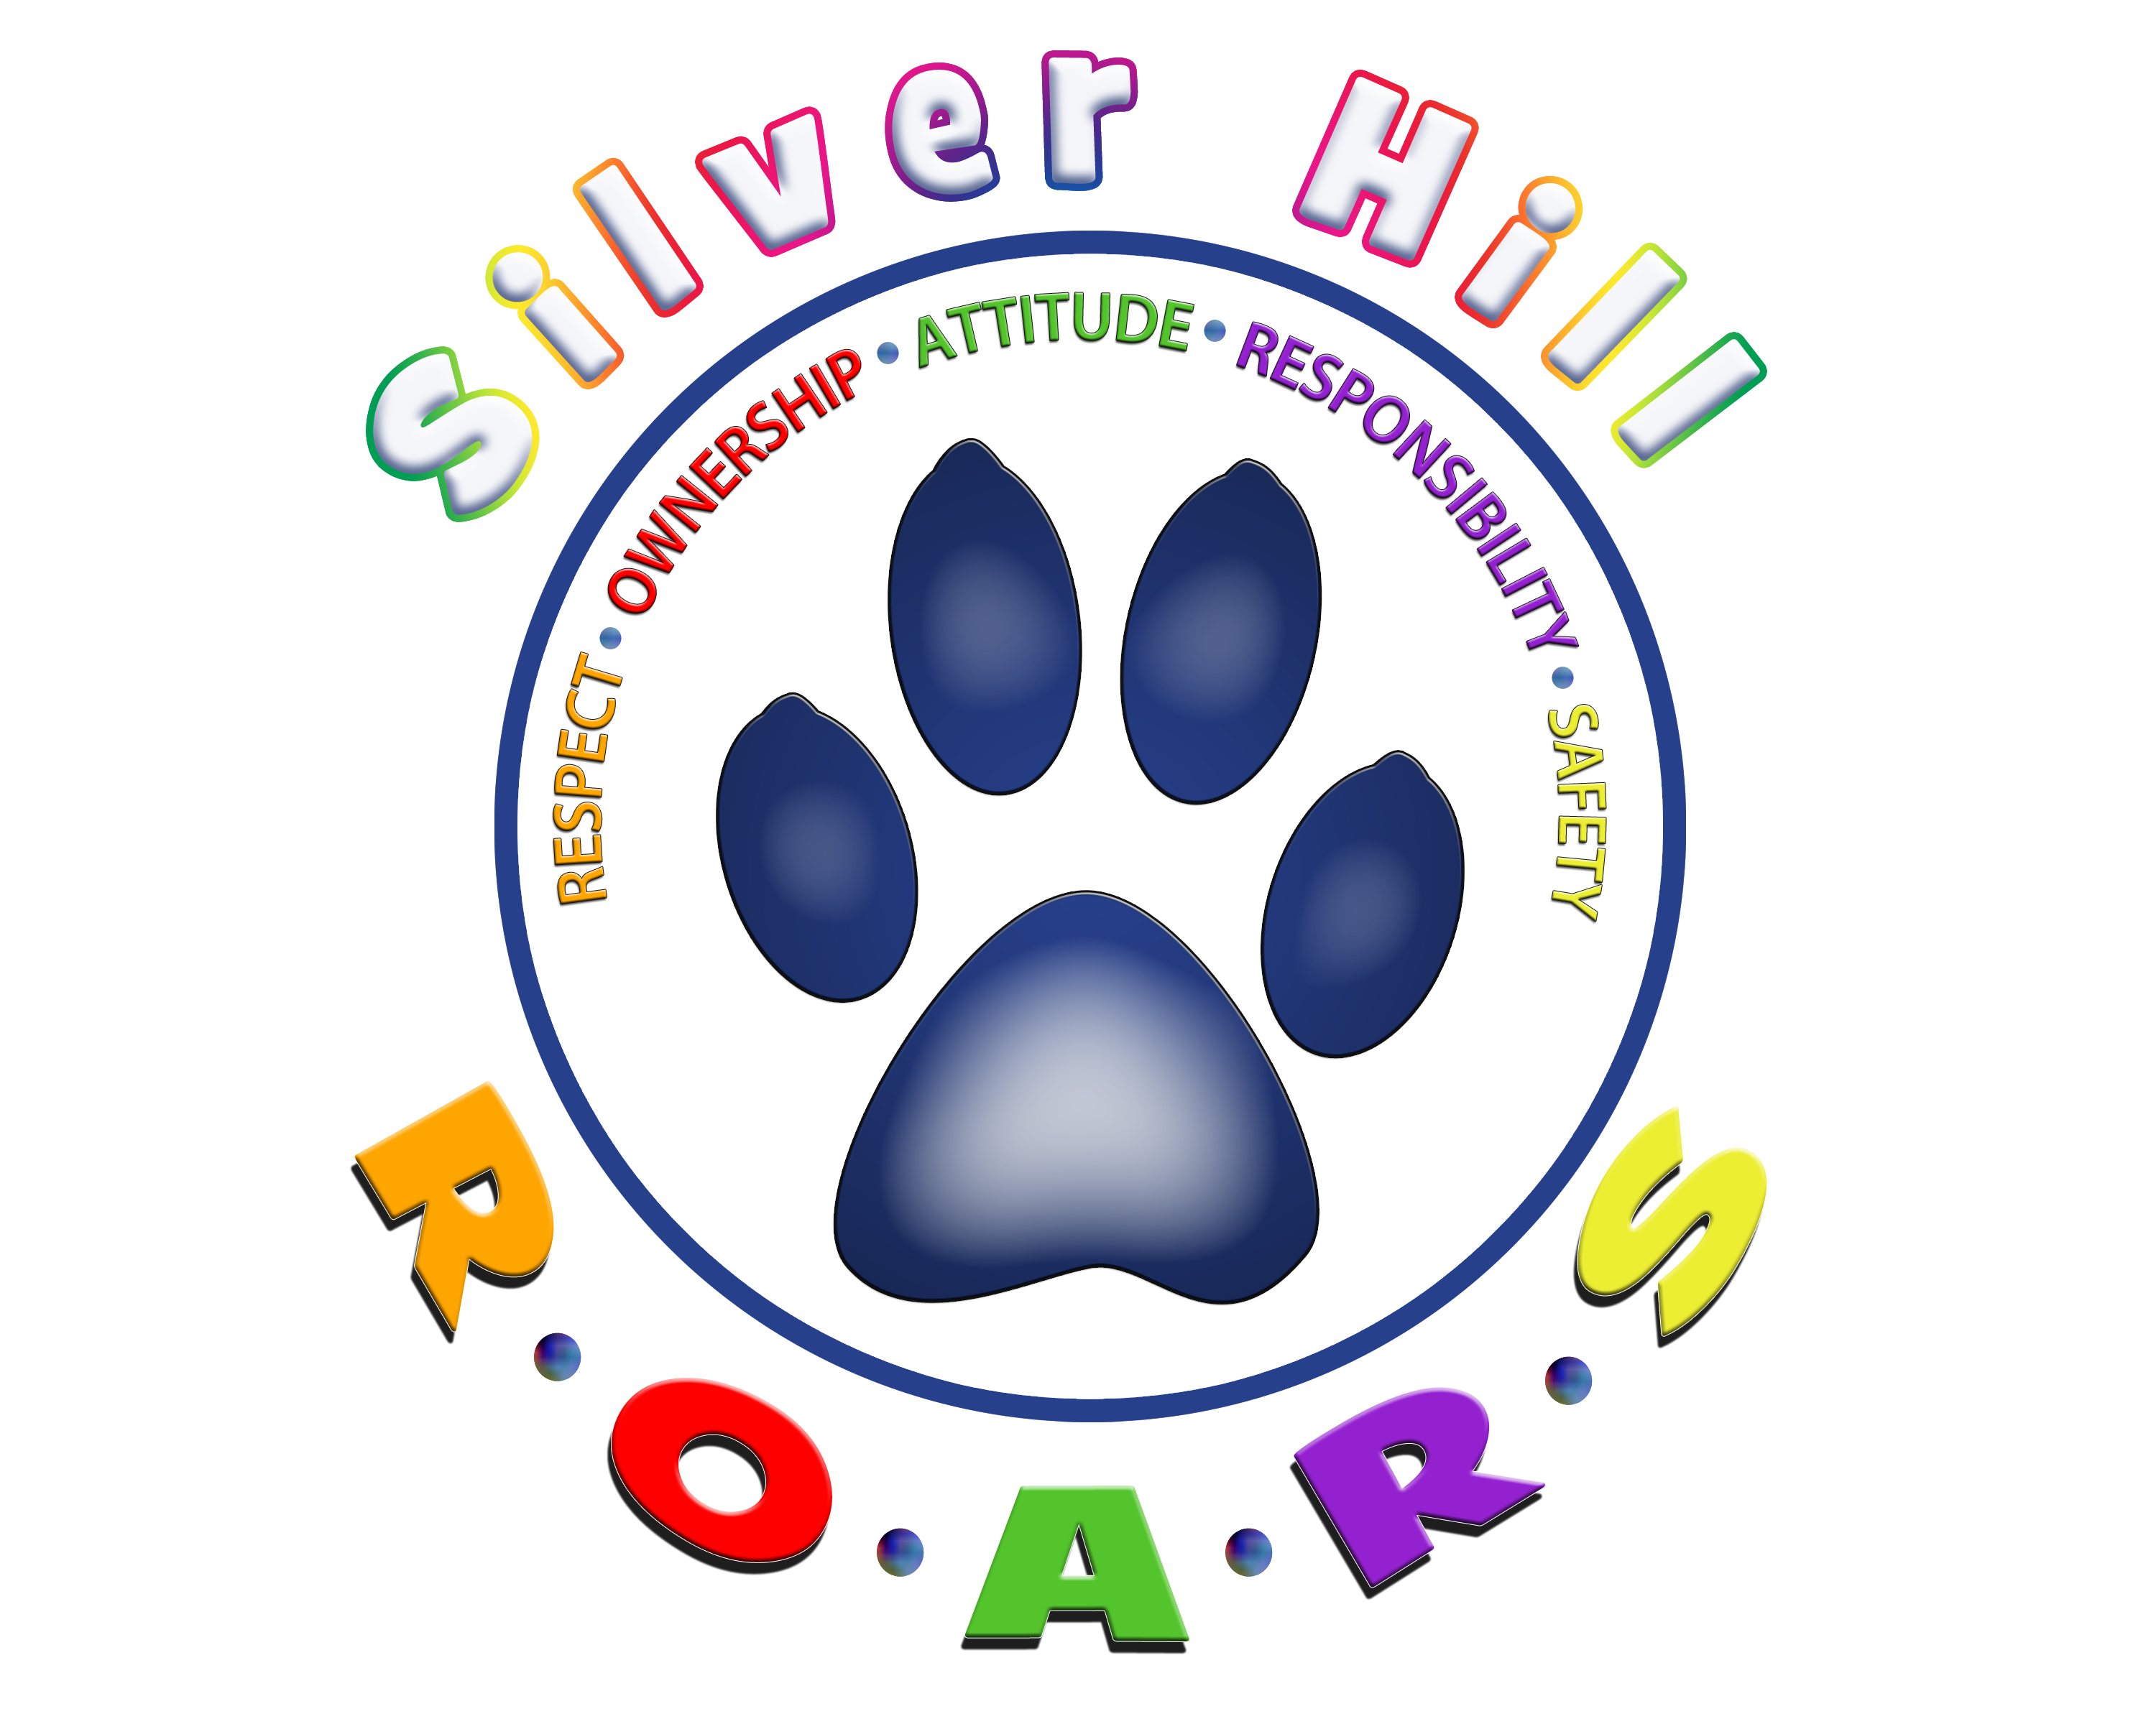

A Silver Hill Jaguar ROARS

There are no excuses, a Jaguar ROARS
Get ready ‘cause we love our school!
I sing it now, I sing it loud...
I've got the heart of a Jaguar,
Respectful
Own my behavior
Attitude’s great
Responsible for myself
Safe, always, at our school
‘Cause I am a Jaguar and
a Silver Hill Jaguar ROARS!

This year Silver Hill will be implementing the Positive Behavior Interventions and Supports (PBIS) curriculum to be used along with Second Step as our social-emotional curriculum. Training was provided for the PBIS Team by the May Institute last spring, with follow up work during the summer to create the school’s Vision and logo, lesson plans, and special events to introduce PBIS to our students. There will be all-staff training throughout this year. PBIS is data driven; our goal is to reduce office referrals for behavior incidents, and decrease the number of playground related accidents. Silver Hill has three areas of focus this year: playground, cafeteria, and hallways (this includes assemblies). As I tell the students, my job is to keep them safe and happy…staff, too! We want to ensure that our students feel safe in all areas of our school, following the same consistent rules throughout the school and on the playground. This includes both physical and emotional safety, reflecting our school-wide vision that Silver Hill is a safe and happy place to learn, and every child feels accepted and appreciated.
To help make the playground safer, and ensure that no child ever feels excluded, we have gone to a structured playground model, with a variety of “stations” that will appeal to every child. We are fortunate to have two beautiful fields, so the playground stations have been set up on each side of the building to allow us to have two grades out at recess at the same time. The four current stations in place are:
• Kickball –A game will be pre-taught in gym with Mr. Hart, so all children are following the same rules. There will always be one supervised active game at recess.
•Legos-Board Games – Our most popular station so far!
•Four Square – The old classic!
•“Hang Out”/Buddy station – This station is for children who just want to relax and chat with friends at recess. We have coloring books, flash cards (to play school!), magnifying glasses, jump ropes, sidewalk chalk, etc.

Although tag is not allowed, as this was out #1 cause of playground accidents,
children are allowed to walk/run around the field, and we are working on creating some type of “track”. Suggestions are welcome! We are asking that no balls be brought from home. Many of the balls brought from home were too hard, another cause of accidents in the past. We will provide all of the equipment from school. Of course donations such as Legos, games, “Quiet Activities” are always appreciated. And when the snow comes, snow gear will be on our Wish List!

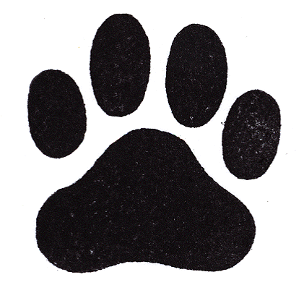

We are excited to start our Positive Behavior Interventions and Supports system at Silver Hill Horace Mann Charter School this year!
WHAT IS PBIS?
- Positive Behavior Interventions and Supports (PBIS) is a framework to address school wide, classroom and individual student social, emotional, and behavioral concerns.
- It includes all students, all staff members and guardians for it to be successsful.
WHAT BEHAVIORS WILL BE TAUGHT AND HOW WILL STUDENTS LEARN THESE BEHAVIORAL EXPECTATIONS?
- We have created a fun easy to remember acronym with each letter representing behavioral expectations that we will teach and reinforce. Our acronym is ROARS: Respect, Ownership, Attitude, Responsibility, Safety (See matrix)
- Students will be taught specific behavioral expectations through direct instruction on the above character traits in locations throughout the school. Students will be expected to demonstrate behavioral expectations in all school settings.
- All students attended an assembly in the beginning of the year to explain our acronym and other aspects of PBIS.
- Hallways, lunchroom, and classrooms will have our matrix displayed as visual reminders for students.
HOW WILL STUDENTS BE RECOGNIZED WHEN DEMONSTRATING EXPECTED BEHAVIOR?
- Students will earn tickets for demonstrating ROARS!
GIVING OUT TICKETS
- Tickets will be distributed to students when they show ROARS behavioral expectations. All staff members will have the chance to give out tickets.
- When a student receives a ticket, they are required to write their name on the front of the ticket and their room number.
- Students are responsible for holding onto their own tickets. It will be up to the teacher’s discretion on how to help students with organizing their tickets.
- Students may choose to accumulate or save tickets for more than one week to submit a large number of tickets at one time. Students will have an opportunity to turn in their tickets on Fridays.
- Students also have an opportunity to earn large Paws for class compliments. The classroom teacher has the student created paws to post on the wall when the class receives a compliment. After 25 (or amount of class members) paws are earned the class can have a class reward.

A school song was created using Katy Perry’s song, Roar, using the ROARS behavioral expectations. The students will be learning the song this year.

